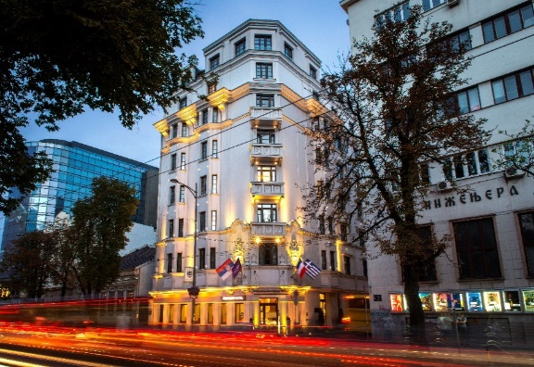

Reservation Form for
eEuropean Society for Vascular Surgery
04.10.-11.10.2026.
With MERCURE Belgrade Excelsior Hotel

First Name: ____________________ Last Name: _________________________
Room type with buffet breakfast - BB:
☐ Superior room single use 110 $EUR$ ☐ Superior room double use 121 $EUR$
☐ Privilege room single use 132 $EUR$ ☐ Privilege room double use 143 $EUR$

*The Superior room can be booked either with a king-size bed or two separate twin beds.
Room rates include: Bed and Breakfast, VAT, Wireless internet in the room and public area.
The room rate is per night per room.
Room rates exclude: City tax which is 1.40 EUR per day, per person.

Arrival Date: 10/4/2026 Departure Date: 10/11/2026
(Check-In Time from 15:00) (Check-Out Time until 12:00 noon)
Reservation guarantee: No reservations will be confirmed nor guaranteed unless credit card details are provided.

Credit card type/name: Visa Credit card number:___________________
Expiration date: ___/_______________ Card holder name: __________________
By signing this, I guarantee the above booking to this credit card and accept the terms of cancellation below.
Signature of cardholder: ___________________________________
By signing this I guarantee the above booking to this credit card and accept the terms of cancellation:
Guests will pay all expenses directly in hotel by their credit cards.
Reservation form with credit card details will be used for hotel accommodation/reservation guarantee (credit card will be preauthorized).
Reservations can be modified or cancelled up to 3 days prior the arrival date. For every reservation cancelled after mentioned deadline, the guest will be charged for the amount of one night rate.
In case of guest’s non-arrival (i.e. no show), the guest will be charged for the full amount of the stay.
Please send the completed form to Sales Department at following email: mina.pesic@accor.com or Ljubica.markovic@accor.com

Looking forward to welcoming you to our hotel,
Sales Department
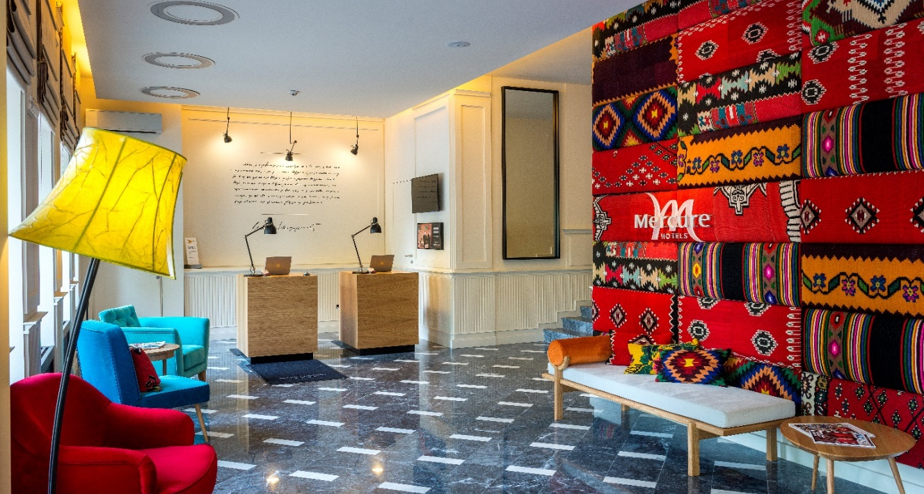

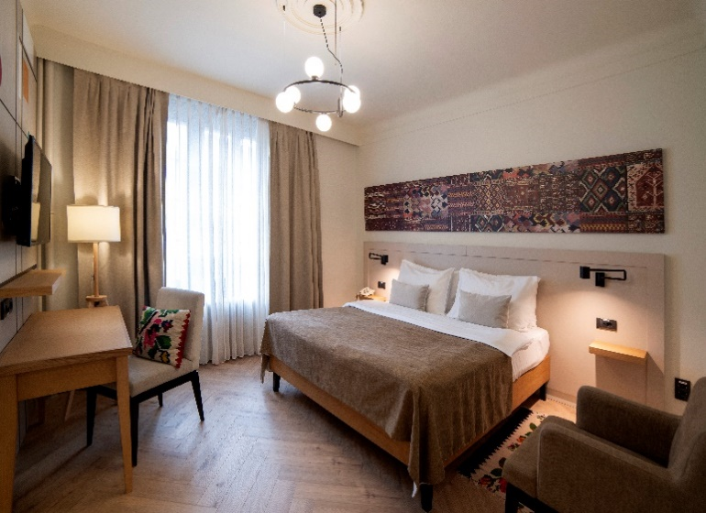
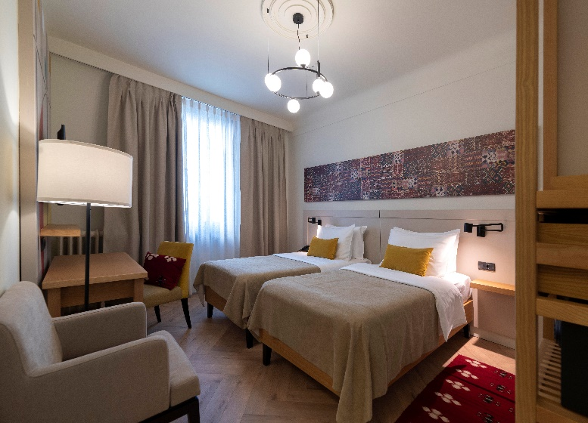
Superior room with king size bed Superior room with twin beds

:

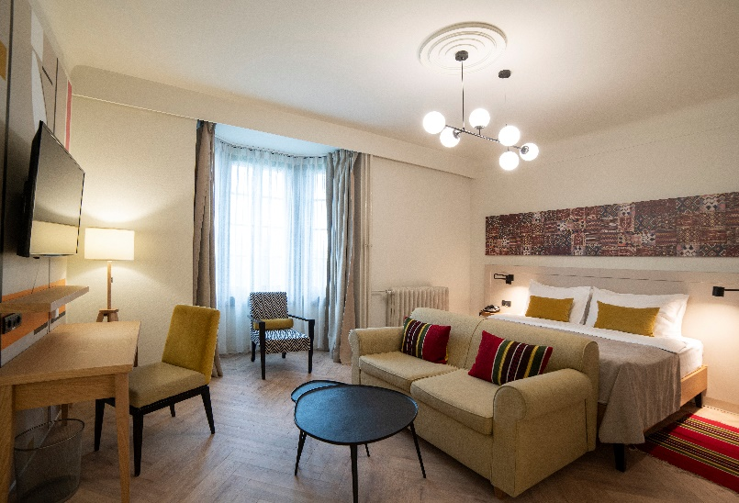
Privilege room

